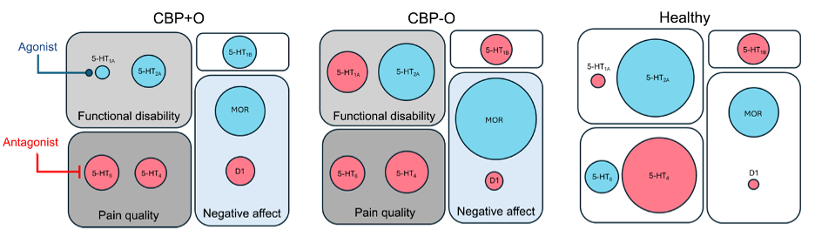
Figure 6. Summary of multi-molecular adaptations in chronic back pain and with long-term daily opioid use. The influence of the six receptor circuits contributing to opioid use and to CBP phenotypes on brain activity is summarized for the CBP+O, CBP-O, and healthy (circle size = effect size, red = increased activity, blue = decreased activity). The figure also indicates that, given these results, a 5-HT_{1a} agonist drug and a 5-HT₆ antagonist drug may be viable routes for aiding opioid tapering and managing chronic pain.

